Subject: Music
Section: Music Theory
Lesson: Sound and Music (notes 001)
Vocab:
Music, Sound, Composer, Performer, Improvisation, Soundwaves, Frequency, Amplitude
Music is the art of the organization of sound in time. Music is usually made through the use of instruments, but music is not completely limited to instruments. To make music, you need a timeframe, soundwaves, and cognition (the ability to perceive and process sound as music or an art). Few animals, such as humans and birds, have the ability to perceive music. Music binds humanity together because of this.
Sound is how humans perceive movements in air. These movements are called soundwaves. Air is required to make sound. There is no sound in space.
The creator of any piece of music is called a composer. A performer generates the sounds written by the composer. A performer can be either a human or machine. A human uses an instrument to reproduce sound, as a machine uses a speaker to reproduce sound. Machines can record sound. Improvisation is when composition and performance happens simultaneously.

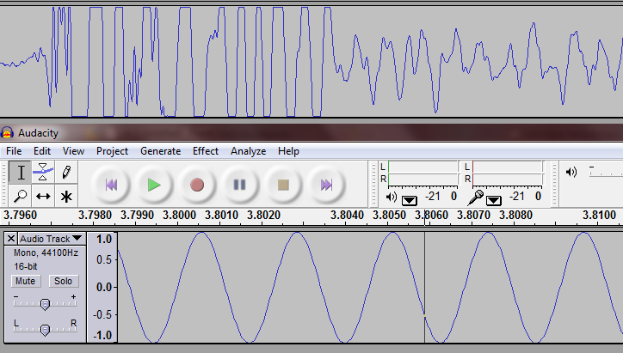
Frequency is the distance between one wave and another. A high frequency has very close waves. High frequencies produce high sounds.
Amplitude is the height of the wave. The taller the wave, the louder the sound.
The top soundwave is an actual recording of me clapping my hands. The wave has an irregular frequency, so it does not produce a pitch. The bottom wave is a sine wave, and it is uniform, so it produces pitch. Pitches are very important because they are the building blocks of music. Almost all instruments produce a pitch. Most percussion, however, is pitchless.
Music is cultural. There are major differences between Western and Non-Western music. Russian music is Western.

Subject: Music
Section: Music Theory
Lesson: Elements of Music (notes 002)
Vocab:
Pitch, Duration, Timbre, Dynamic, Articulation, Note
Pitch is the highness or lowness of a sound. It is the most important element in music. Pitch is also known as frequency.
Duration is the length of time in which sound lasts. It is the second most important element of music. Duration is also known as wavelength.
Timbre (pronounced TAM-ber) is what type of sound or groups of sound it is. The pitch “A” sounds different on a violin and flute, and the violin and flute differ because they have different timbres. The word timbre can be applied to wide, general categories. For example, the timbre of stringed instruments is different from the timbre of keyboard instruments. Timbre is also known as waveform or color.
Dynamic is the loudness of a sound. It is also known as amplitude.
Articulation is how sound is modified. You can modify the attack, sustain, and decay of a sound to alter it completely. Attack is how a note is initially played, sustain is how it is held, and decay is how it is released. It is also known as envelope.
A note is a symbol in music that represents one or more of the following: pitch, duration, timbre, dynamic, and articulation.

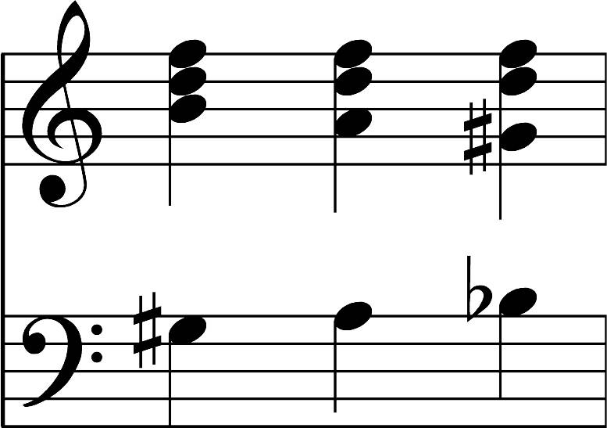
This is the grand staff. Grand staves are simply graphs. The y axis is pitch, and the x axis is duration.

Subject: Music
Section: Music Theory
Lesson: Instruments as sound sources (notes 003)
Vocab:
Ethnomusicology, Chordophones, Aerophones, Membraphones, Idiophones, Strings, Brass, Woodwinds, Percussion, Keyboard, Theremin, Musique Concrete, Electronic Music
Ethnomusicology is the study of music of other cultures.
Instruments produce sound in different ways. These different ways sound is produce is why instruments have different timbres.
Chordophones have strings that vibrate the air (violin). Aerophones directly vibrate the air (flute). Mebraphones have a membrane that vibrates struck (drums). Instruments where the whole body vibrates are idiophones (xylophone). Electrophones depend on electricity.
Families are groups of instruments: Bowed and plucked instruments with strings are stringed instruments. Instruments that are made of metal that vibrate air are brass instruments. Woodwinds vibrate the air with the breath alone. Percussion are struck to produce vibrations. Keyboards produce chain reactions from hitting keys.
A Theremin is the first electronic instrument.
Musique concrete is the original process of creating music. It is the foundation for modern day music production.
Composers produce music by recording, editing, and mixing.
Electronic music is music that cannot be produced by a human performer alone.

