Subject: Music
Section: Music Theory
Lesson: Durations (Notes 4)
Vocab:
Duration, Beat, Tempo, Rhythm, Time Signature, Measure, Quarter Note, Half Note, Whole Note, Eighth Note, Sixteenth Note, Dot, Rests
A duration is the length of a note. Rhythm is the way music is organized in time. A series of durations creates a rhythm.
A beat is a steady rhythm that is not always audible in music. If you were to count to a tune, you would be counting its beats. How fast the beat is (and overall, the speed of the song is) called the tempo. Tempo is measured in Beats Per Minute (BPM)

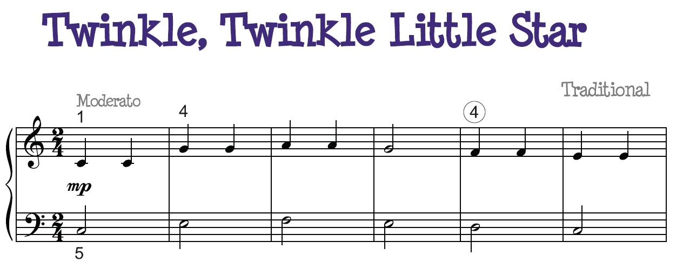
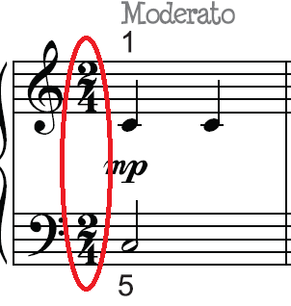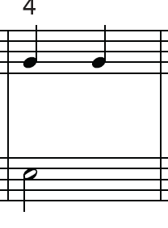
A B C D
A) A time signature tells you which and how many beats there are in a measure. In this arrangement of Twinkle Twinkle, the time signature is 2/4. The number on top tells you how many beats there are in a measure. There are two beats per measure in this song The number on the bottom tells you which note gets the beat. A four means a quarter not gets a beat, an eight means an eighth note gets a beat, a two means a half note gets a beat, and a sixteen means a sixteenth note gets a beat.
This would be counted:
Twin kle Twin kle Lit tle Star
One Two One Two One Two One Two
B) A measure is an organization of the beat. The number of beats per measure can be found in the time signature.
C) A bar line separates measures.
D) This is the tempo. It is at moderato, which means moderately.

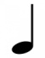 This is a quarter note. It receives one beat in 4/4 time.
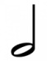 This is a half note. It is worth two beats in 4/4 time. It is equal to two quarter note.
This is a whole note. It is worth four beats in 4/4 time. It is equal to two half notes.
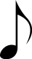 This is an eighth note. It is worth half a beat in 4/4 time. Two eighth notes make a quarter note.
These are two eighth notes. They are connected with a beam.

This is a sixteenth note. It is worth a fourth of a beat in 4/4 time. Four sixteenth notes makes a quarter note.
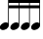 These are four sixteenth notes.
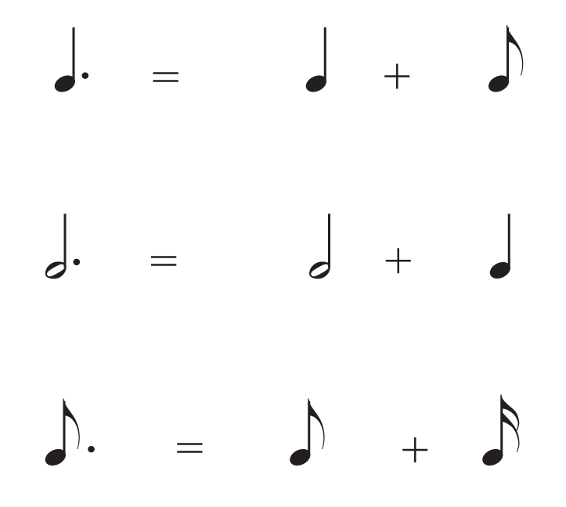
A dot means add half the duration of that note to that note. A dotted half note is worth three beats.

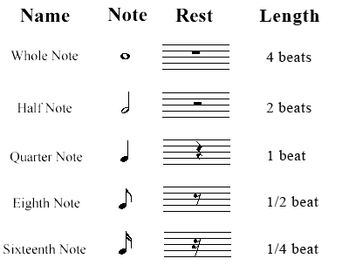
A rest represents silence. Like notes, it is counted in beats.

